Test Case: tc001_SPX_Dev5_Crear_Solicitud_Articulo_Almacen
Step 1 - Enter username and password and click to button Enter : Credentials Entered
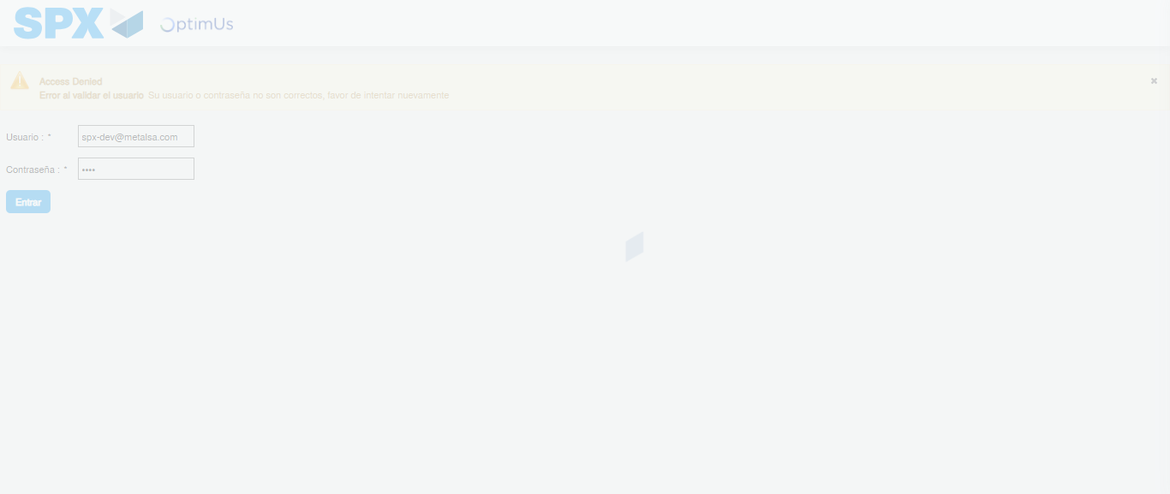Image file-name: QC_Testing-tc001_SPX_Dev5_Crear_Solicitud_Articulo_Almacen-1787931653139

Step 2 - Select to UEN and Access to Request for a New Inventory Item : UEN Correctly selected and Correct access
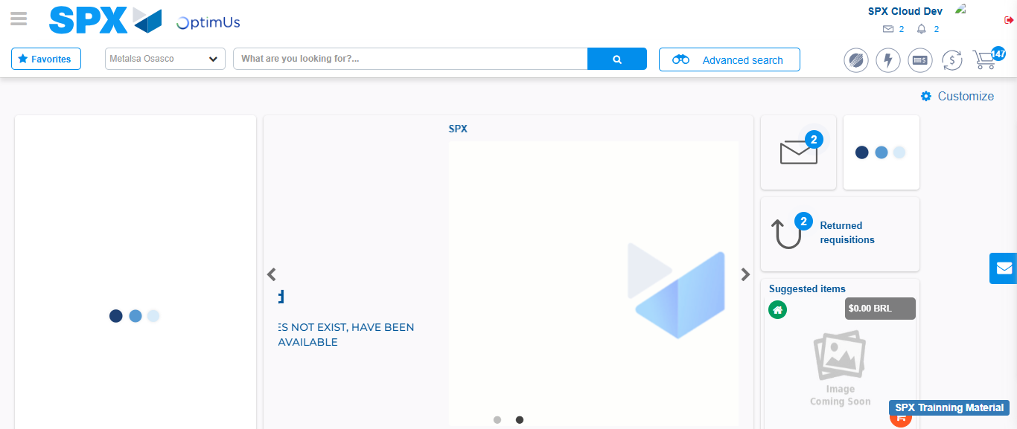Image file-name: QC_Testing-tc001_SPX_Dev5_Crear_Solicitud_Articulo_Almacen-1787931678935

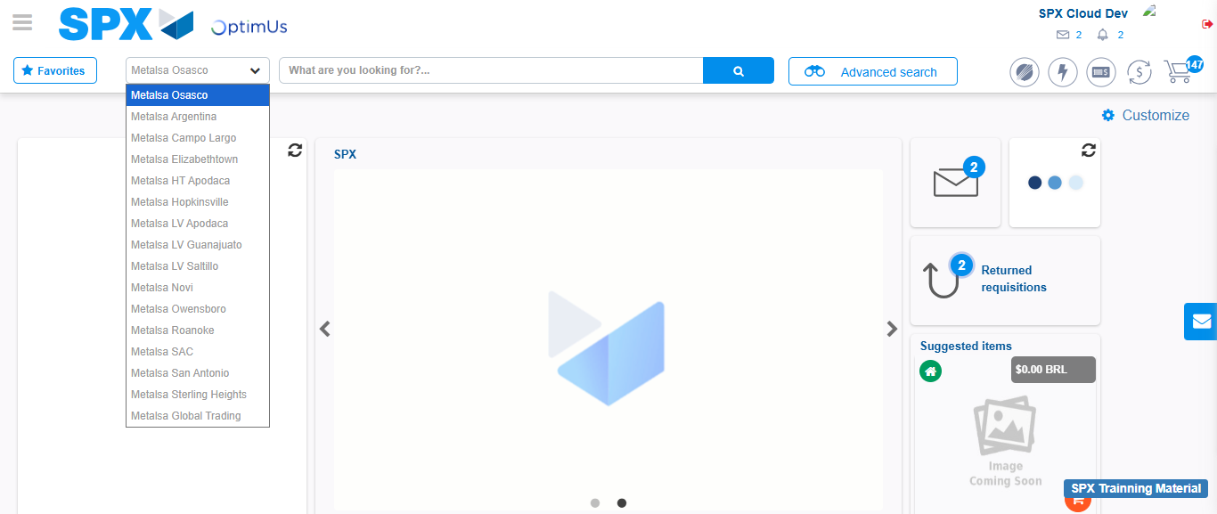Image file-name: QC_Testing-tc001_SPX_Dev5_Crear_Solicitud_Articulo_Almacen-1787931679509

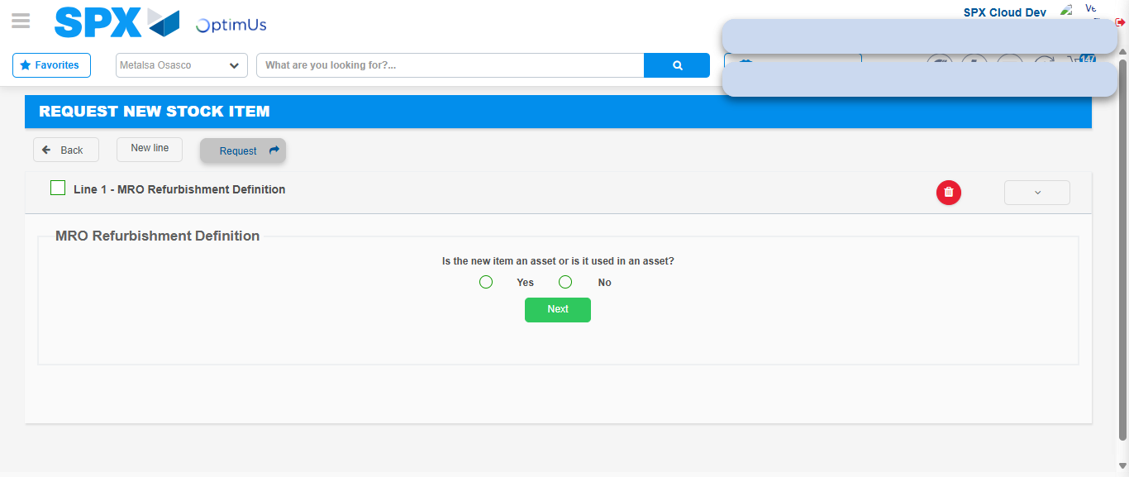Image file-name: QC_Testing-tc001_SPX_Dev5_Crear_Solicitud_Articulo_Almacen-1787931708236

Step 3 - Select options first section : Options seleted correctly
Image file-name: QC_Testing-tc001_SPX_Dev5_Crear_Solicitud_Articulo_Almacen-1787931708499

Image file-name: QC_Testing-tc001_SPX_Dev5_Crear_Solicitud_Articulo_Almacen-1787931708677

Step 4 - Select options at Screen: Options seleted correctly
Image file-name: QC_Testing-tc001_SPX_Dev5_Crear_Solicitud_Articulo_Almacen-1787931708499

Image file-name: QC_Testing-tc001_SPX_Dev5_Crear_Solicitud_Articulo_Almacen-1787931708677

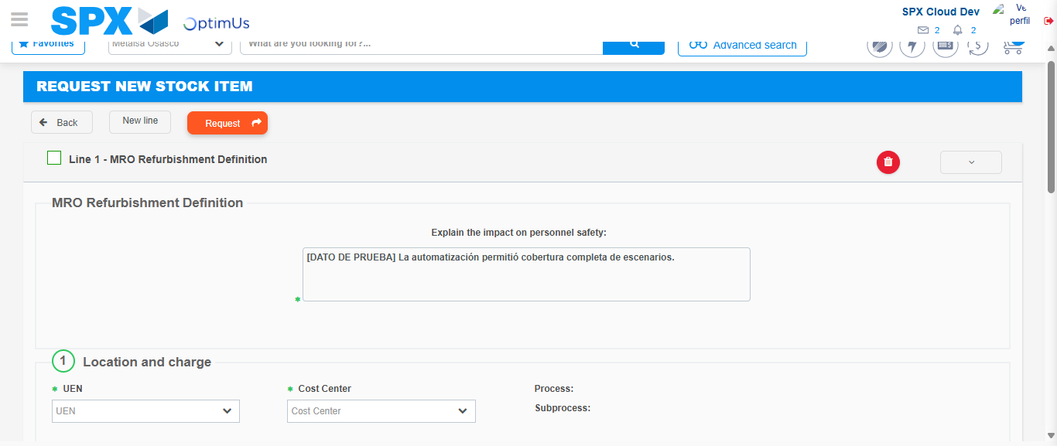Image file-name: QC_Testing-tc001_SPX_Dev5_Crear_Solicitud_Articulo_Almacen-1787931714723

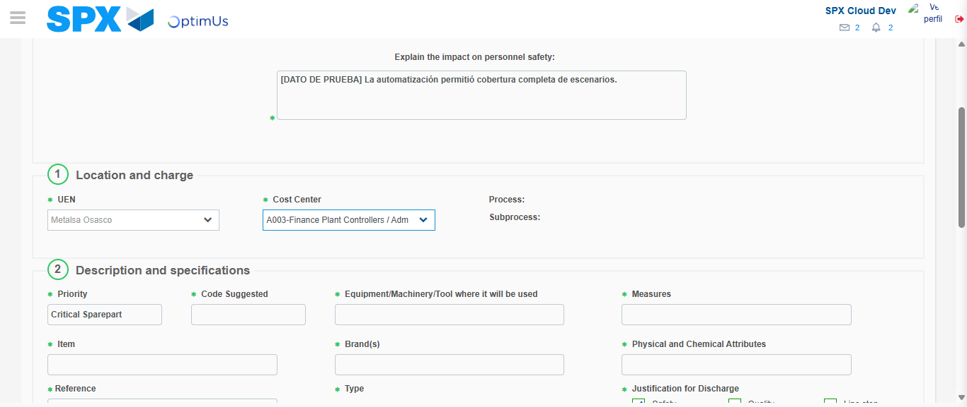Image file-name: QC_Testing-tc001_SPX_Dev5_Crear_Solicitud_Articulo_Almacen-1787931717153

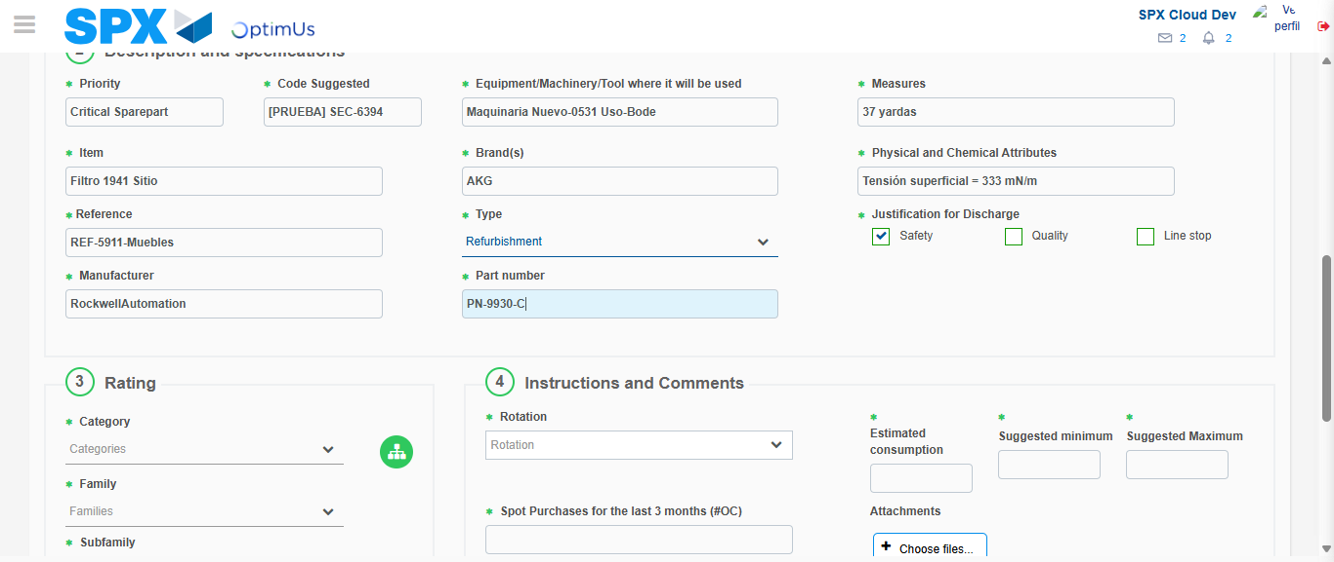Image file-name: QC_Testing-tc001_SPX_Dev5_Crear_Solicitud_Articulo_Almacen-1787931718432

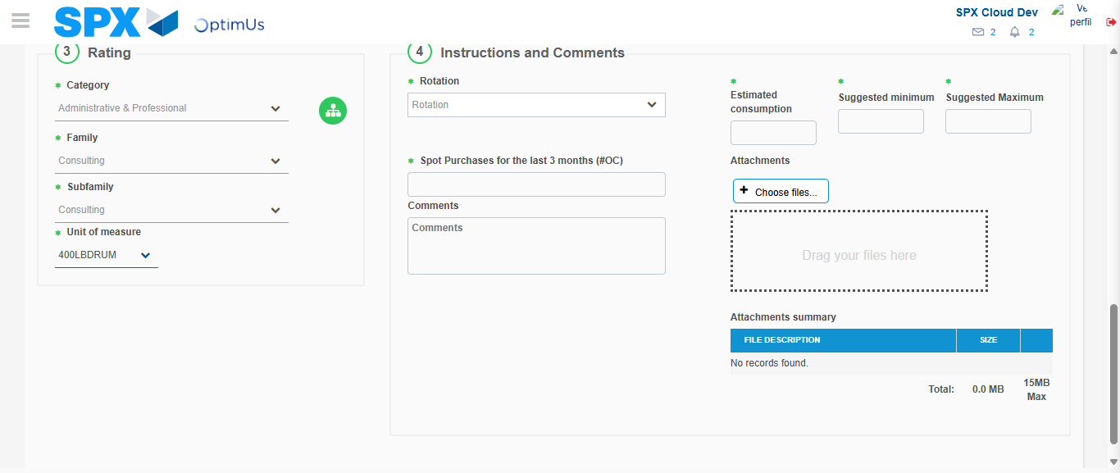Image file-name: QC_Testing-tc001_SPX_Dev5_Crear_Solicitud_Articulo_Almacen-1787931722661

Step 5 - Request New Item : Request Accepted
Image file-name: QC_Testing-tc001_SPX_Dev5_Crear_Solicitud_Articulo_Almacen-1787931678935

Image file-name: QC_Testing-tc001_SPX_Dev5_Crear_Solicitud_Articulo_Almacen-1787931679509

Image file-name: QC_Testing-tc001_SPX_Dev5_Crear_Solicitud_Articulo_Almacen-1787931708236

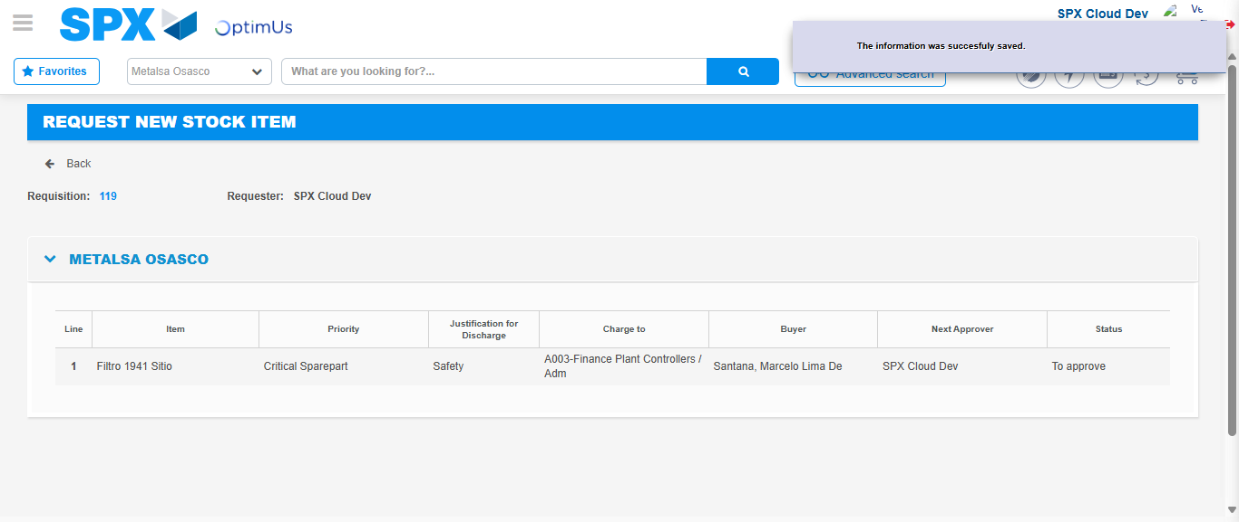Image file-name: QC_Testing-tc001_SPX_Dev5_Crear_Solicitud_Articulo_Almacen-1787931729551

Image file-name: QC_Testing-tc001_SPX_Dev5_Crear_Solicitud_Articulo_Almacen-1787931729697

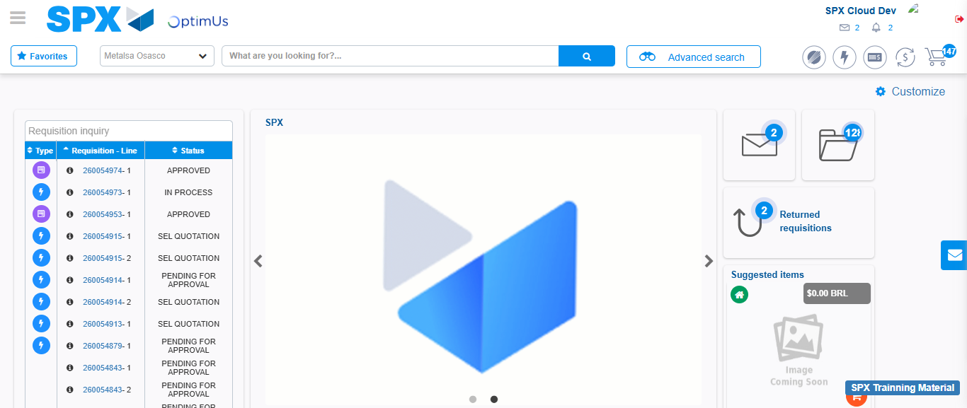Image file-name: QC_Testing-tc001_SPX_Dev5_Crear_Solicitud_Articulo_Almacen-1787931750847

Step 7 - Return to Main Page SPX : Return to Main Page SPX
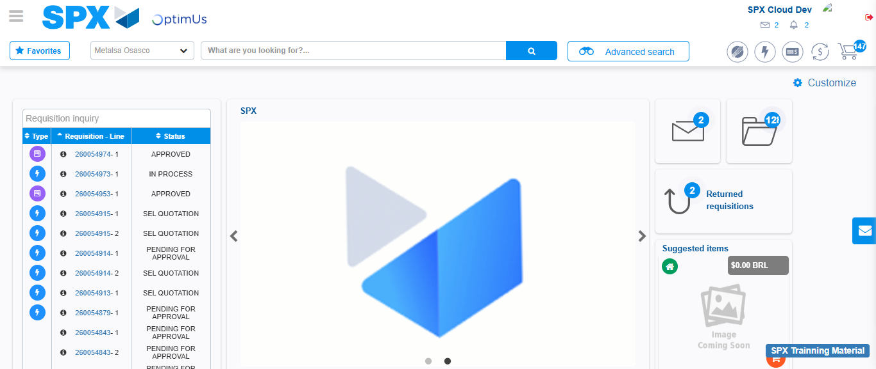Image file-name: QC_Testing-tc001_SPX_Dev5_Crear_Solicitud_Articulo_Almacen-1787931751114

